Affiliate Marketing
Assignment Report

Name: Josva Rochi. R
Email: josva6438@gmail.com

Introduction

Affiliate marketing is a process where individuals promote products online and earn a commission for each purchase made through their affiliate link.
In this project, I created an Amazon Associates account and selected a product to promote using my affiliate link.

Account Creation

I signed up for the Amazon Associates program by entering my details and verifying my account.
Below is a screenshot of my Amazon Associates dashboard.

fig :1

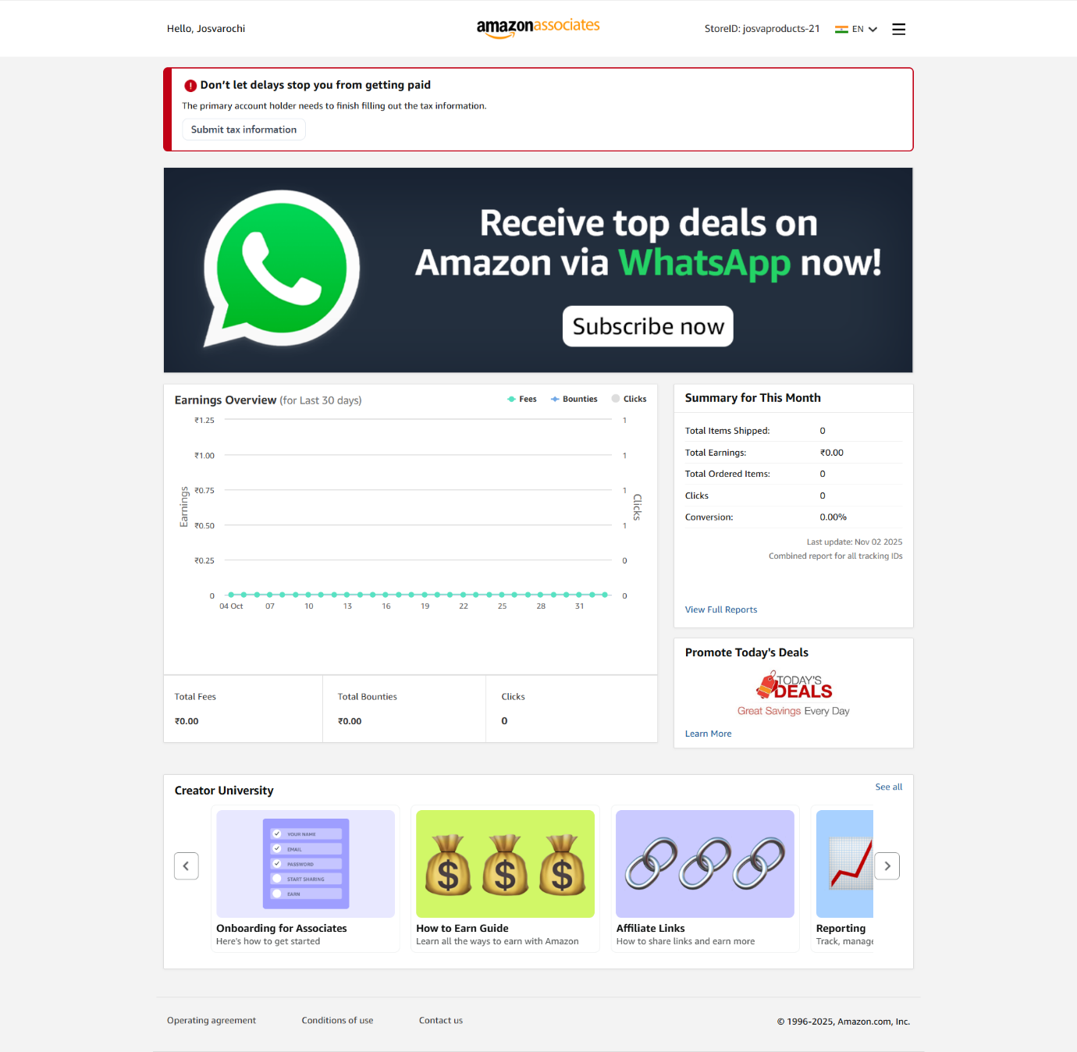

Product Selection
I selected a travel product that aligns with my audience’s interests.
Product Chosen: LOVEVOOK 40L Carry-On Travel Backpack
Category: Travel Accessories
Price: ₹1,885.00

Fig 2:
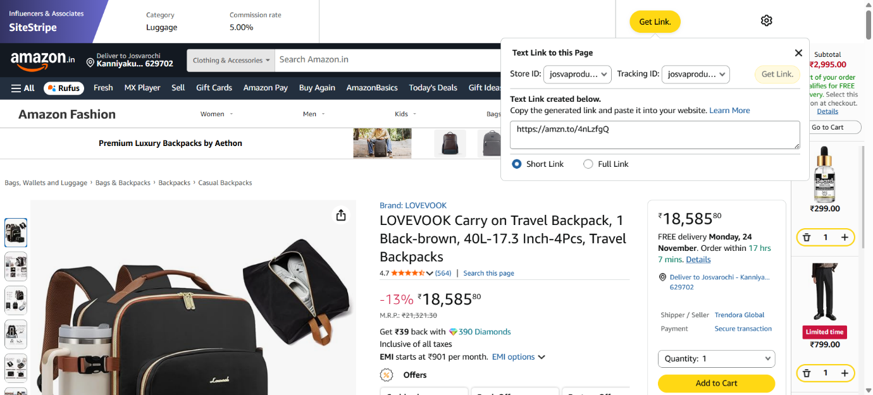

Amazon link creation
Using the amazon site stripe tool I generated my affiliate link for the selected product.
Link: https://amzn.to/4nLzfgQ

Traffic plan
To promote the product, I plan to use social media platforms such as Instagram and Facebook.
I will create travel related posts and short reels.
Add my affiliate link in captions and my bio.
Share posts in travel related groups and pages.
This will help to get traffic, click and buyers.

Conclusion
Through this assignment, I learned how affiliate marketing works and how to create and promote an affiliate link using the Amazon Associates program.

